**Smart Irrigation System using Cisco Packet Tracer**

**AIM**:

To design and simulate a smart irrigation system in Cisco Packet Tracer that monitors soil moisture and automatically controls water supply, ensuring efficient water use and improved crop yield.

**PROBLEM STATEMENT:**

Traditional irrigation causes water wastage and poor crop management. A smart IoT-based system is needed to monitor soil moisture and automate irrigation for sustainable agriculture.

**SCOPE OF THE SOLUTION:**

The system uses IoT sensors, controllers, and actuators in Cisco Packet Tracer to monitor soil moisture and trigger irrigation automatically, with remote monitoring via smart devices.

**REQUIRED COMPONENTS:**

**Software / IDE**

* Cisco Packet Tracer (IoT-enabled version, 7.2 or above)

**Hardware (Simulated in Packet Tracer)**

* Water level monitor
* Smart Devices (Smartphone / PC for monitoring)
* Wireless Router (for IoT communication)
* Cloud Server (optional, for IoT integration)

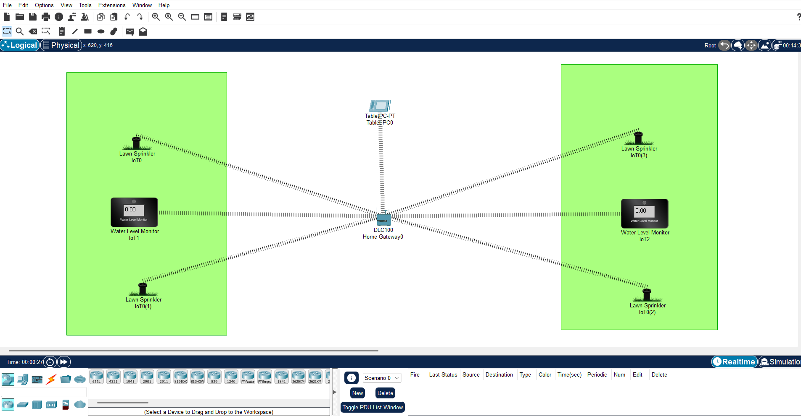**SIMULATED CIRCUIT (TINKERCAD/FRITZING/ CISCO PACKET TRACER):**

VIDEO OF THE DEMO / SCREEN CAPTURE OF THE DEMO:

**DOUBLE TAP THE PLAY BUTTON TO PLAY THE VIDEO**

**By:**

**C.Alwin Salmon**

**Prithiv Raj**

**Aashitha shashi**

**Alphi john**